**Fidelity Case Report - Integrated Business Case Competition**

**Team 9**

Laci Kieschnick

Isaac Stubbe

Corbin Klopfenstein

Jonathan Compton

Sal Salinas

Nicholas Gross

**Table of Contents**

Executive Summary. 3

Section 1. 4

Five Forces Analysis. 4

Competitive Rivalry - Strong Force. 4

Threat of New Entrants - Medium Force. 4

Supplier Power - Medium Force. 4

Buyer Power - Medium Force. 4

Threat of Substitute Products - Low Force. 4

Drivers of Change. 4

Shifts in Target Market 4

Client Experience. 5

High Tech Software. 5

Value Proposition. 5

Changing Demographics. 5

Biggest Problem.. 5

Organizational Performance Matrix. 6

Overview.. 6

Fidelity SWOT Analysis. 6

Diamond Model to Identify Strengths. 6

Section 2. 6

Section 3. 8

Section 4. 10

Conclusion. 11

Works Cited. 12

Section 1. 12

Section 2. 12

Attachments. 13

# 

# **Executive Summary**

The objective of this report is to observe the financial services industry to identify drivers of

change then compare those findings to the current strategy and organizational capabilities of

Fidelity Investments. From this assessment, we will identify potential gaps and create a

business proposal that can take advantage of those gaps. The proposal will include details on

what changes will be necessary to current organizational capabilities as well as the

implementation plan and expected ramifications.

The financial services industry is broken into several segments that are highly competitive and

highly regulated. It is typically dominated by the larger firms and is viewed as less attractive by

potential new entrants. However, with continual improvements in technology smaller tech-based

startups are beginning to attempt to break through. Although Fidelity does an amazing job of taking care of their current investors, they are now faced with the challenge of trying to attract younger investors. The baby boomer generation is retiring and ceasing to invest. Millennials are the upcoming generation and Fidelity needs to find a way to attract young investors. They may have great customer service, and services at low costs, but the problem is convincing this younger crowd to invest so they can maintain their value proposition.

Fidelity’s large amount of resources and history of integrity allows them to have a good fit

between their strategy, organizational capabilities, and environmental demands. Our analysis included two proposals; educating potential customers on investing practices and strategies and micro-investing.

Implementation of the micro-investing would be fairly simple. Fidelity would start by acquiring Acorns. Acorns is an app based investing platform that connects right to your bank. We expect researching and acquirement to take a total of 270 days with a cost of $407,500,000. First year’s revenue is projected to be $37,620,000 with revenue reaching $262,140,000 after 5 years. Overall, we feel that this proposal creates a new way to generate revenue with potential to add

new offerings to the platform. It also will provide Fidelity opportunities to reach younger

demographics to educate them in all of Fidelity’s line of offerings.

# 

# **Section 1**

## **Five Forces Analysis**

### **Competitive Rivalry - Strong Force**

The competitiveness amongst the firms in the financial services industry is very high. This allows consumers to have access to several options when it comes to stock investing, retirement planning, etc. Differentiation between the firms is key, and distinguishes them from competitors by offering the best returns, financing, investment services, and client experience.

### **Threat of New Entrants - Medium Force**

Trust it the biggest factor for a potential/current investor when it comes to choosing a firm to work with within the financial services. This determining factor makes any threats of new entrants in the industry very low. Building trust and intrapersonal relationships with consumers takes time and effort and it is not achievable overnight. Investors tend to choose one firm and continue to be loyal to them as long as their needs/wants are being satisfied.

### **Supplier Power - Medium Force**

The industry is based on the amount of capital invested in a firm by consumers, which in turn, creates the supplier power. Several firms offer investment options that are self-created to give consumers multiple choices which bring in more assets directly to the firm. Consequently, firms’ products in this industry are extremely similar. Products such as stocks, bonds, funds, options, commodities, and foreign exchange. The difference being the composition and platforms.

### **Buyer Power - Medium Force**

The power of the buyer has increased marginally with the help of the internet. Consumers now can research better options online, also having the ability to access and manage all their accounts with just the use of their cell phones. Individually, the bargaining power for consumers in this industry is low. Firms attempt to increase market share by capitalizing on trends in preferences of the consumers and by creating value that is meaningful to the masses.

### **Threat of Substitute Products - Low Force**

The threat of substitute products is low in this industry. Due to the fact, that consumers do not have many alternatives to choose from. Any investing in the stock market**,** bonds or foreign currency, are limited to the financial service industry. In this industry, the strict regulations make it extremely difficult for consumers to navigate without a firm acting as an intermediary.

## **Drivers of Change**

### **Shifts in Target Market**

The Baby Boomer Generation is making a transition from investors into people currently retiring. These men and women will begin to live off their investments and cease to invest. This should signify to firms that they must explore other strategies such as focusing on the younger generations. The new industry leaders will be determined by those who achieve the buying power of the Millennial generation as they transition into the workforce and begin to save and potentially invest for the future. One complication is that millennials are struggling to save, and this is an obstacle the firms are going to have to overcome.

### **Client Experience**

Since the firms in this industry offer a limited variation of products, service is a vital component of their value proposition. Firms must heavily focus on client experience to ensure their clients are happy, which in turn will create loyalty. Client Experience will be a key differentiator for years to come. Firms customer service is now rated by several websites. This can be a deal breaker for potential investors has they tend to research who the top firms are. Firms with bad ratings struggle, as firms with excellent ratings draw in more investors.

### **High Tech Software**

Technology and innovation is vital to this industry. Firms strategies should be to invest in a high tech/high quality trading platform that allow clients to have the proper tools to manage their portfolios. Improper technology will make it difficult for firms to attract/retain consumers in this competitive industry. The inability for firms to design their own software should persuade firms to consider buying a smaller firm that wields the necessary technology to keep in pace with competitors.

### ***Value Proposition***

Fidelity does an amazing job by enhancing its value by offering services at low costs, and by exceeding their clients’ expectations. They achieve this by working more closely with them, and by identifying what exactly they can benefit from (fidelity.com). They work to provide the best financial planning service for them. With various offices, clients from all over can visit these which increases the customer base for fidelity. This allows fidelity to create intrapersonal relationships with its clients, which has proved to be very beneficial. They are rated very high on review websites which also allows them to continuously attract potential investors. New investors tend to conduct research on top firms they potentially want to invest in. Fidelity has been awarded Best Online Broker in 2015,2016,2017 by *Investor’s Business Daily.*

### **Changing Demographics**

Although Fidelity does an amazing job of taking care of their current investors, they are now faced with the challenge of trying to attract younger investors. The baby boomer generation is retiring and ceasing to invest. Millennials are the upcoming generation and Fidelity needs to find a way to attract young investors. They may have great customer service, and services at low costs, but the problem is convincing this younger crowd to invest so they can maintain their value proposition.

### **Biggest Problem**

The biggest weakness is obtaining younger clientele. Focusing on millennials, they are struggling to enter that customer base. Much of the customers in the financial services industry are the age of fifty and above. These customers will soon be in the phase of transferring wealth, and in the next couple decades, will no longer be customers. Furthermore, millennials are not investing at a high rate even though this generation will be shifting into adulthood. Fidelity needs to strategize a plan that makes it convenient and attractive to these young potential investors.

## **Organizational Performance Matrix**

### ***Overview***

Please see attachment 1.

The financial position of the company is very good, as well as the profitability. The market performance is also good as well. Combining the two, the performance overall is very good. The firm continues to grow and expand. Its revenue increased 4% from Q2 2015 to Q2 2016. Although they did better the year before, in which revenue increased 8.7%, they still managed to do better than the industry average of 3.9%. The growth is slightly better than the industry average, but the firm made up for it when it came to their net assets flow. They did an amazing job by increasing by 281.5% from Q2 2015 to Q2 2016. They substantially out performed their previous year in terms of growth which was 79.5%. These successes in their profits and health in the firm rely heavily on the reviews that their customers give them. They have a 4.3/5 in ratings in terms of their trading services. The near perfect score reflects the firm’s internal environment that stays true to their core values. According to their review, the firm offers high quality services, they develop intrapersonal relationships with their clients, and they maintain their family feel they want to successfully offer. For all these reasons, this why the firm is placed in the “desired state” quadrant of the performance matrix.

## 

## **Fidelity SWOT Analysis**

Please see attachment 2

## **Diamond Model to Identify Strengths**

Please see attachment 3

(Information retrieved from fidelity.com, data provided to us on blackboard.)

# **Section 2**

Some of the major problems identified for Fidelity was their complexity, high advisory minimums, and limited customer demographic. When looking at Fidelity’s direct competitors these same problems were identified. Due to these problems being industry wide, and our understanding of the upcoming generation, we decided to focus on an opportunity that solves these problems. A few potential strategies to combat these identified problems surfaced. The first was educating potential customers on investing practices and strategies. Videos, classes, and coaches could all be utilized to help this initiative. By being a knowledge resource for the consumers, they would gain investors which were younger or more novice. This strategy would help expand Fidelity’s demographic, grow revenue, and gain long-term loyal customers. Another potential strategy was to lower Fidelity’s advisory minimums. This strategy would have similar effects to the educational agenda listed earlier, expanded customer base, revenue growth, and an increase in long-term loyal customers. This strategy would also simplify investing for a larger base of their customers, which was another major problem identified. The last strategy identified, and the strategy that will be further discussed throughout the rest of this report, is getting into simple micro-investing by acquiring Acorns. This strategy encompasses solutions that would counteract all previously listed weakness, including, complexity, high minimums, and limited customer demographic.

This micro-investment strategy is related diversification for Fidelity. Looking at the 6s’; employ slack, create synergy, shared knowledge, similar business models, spreading capital, and stepping stone to new industries, verifies this related diversification claim. Fidelity will be able to employ slack by leveraging its already existing portfolio investment strategies. Micro-investing will not require to change its current investing strategies, instead it will simply gain economies of scale through growth. By targeting a younger or beginner demographic Fidelity will be able to create synergy. Fidelity will be able to provide services to all demographics; young/novice, intermediary, and advanced investors, through its wide range of micro-investing, index funds, and 401k services. This full range of services creates synergy for Fidelity and its customers. This move into simple micro-investing would still be within Fidelity’s core competencies and thus shared knowledge. Abigail Johnson, CEO of Fidelity, backed this claim during a recent interview on the David Rubenstein Show when she said, “Our goal is to have everything that someone could reasonably want on our platform and make it available to them in a way that is most value added” [i]. I think both Abigail, and potential Fidelity customers, would both agree that a simple micro-investing platform is a reasonable offering for Fidelity due to its similar business model. Another big incentive for Fidelity to implement this strategy would be its consistent earnings. Unlike most investment models, simple micro-investing does not charge a percentage of the investment, it instead charges a small flat monthly rate. This would allow Fidelity to build steady earnings that do not ebb and flow with the market which would spread Fidelity’s capital. Lastly this strategy would be a stepping stone into a new and fast-growing industry. This simple micro-investment industry is still new and there is a lot of room to make a good return.

The proposal for Fidelity to enter the micro-investing industry is a relatively simple one. The first step of the proposal is that Fidelity acquires Acorns. Acorns is the biggest player in the budding micro-investing industry with approximately 2 million users. Acorns is an app based investing platform that links directly to your bank account. The app rounds up each transaction in the linked account to the nearest dollar and invests this change into a custom-tailored portfolio based on your general preferences. To provide this service Acorns charges a $1 monthly fee to accounts under $5,000, and .25% of the amount in accounts over $5,000. After acquiring Fidelity would maintain these major functionalities and customer base. However, Fidelity would re-brand Acorns as a Fidelity company. Fidelity would also maximize the custom-tailored portfolios based on their industry knowledge and scale. Lastly, in time frame of about 6-12 months Fidelity would raise the monthly fee from $1-$1.50. This proposal is relatively simple for Fidelity, but it would differentiate itself from its competitors.

Fidelity is a flexible and privately-owned company that can take risks. For example, Fidelity is one of the few asset management firms that is investing heavily in cyber-currency. This makes Fidelity the best fit, out of its direct competitors, to jump into this emerging industry. After Fidelity makes the acquisition of Acorns they would interact with potential long-term customers in a way that other asset management firms are not. Individuals who wish to dip their toes into investing would be using Fidelity’s Acorns app as a first step. As these same customers gain knowledge and capital and move into more serious investing they are already familiar with Fidelity and its service. This will separate Fidelity from its competitors in the eyes of the young or novice investors.

This proposal will enable Fidelity to gain revenue through three distinct channels. First, and most immediately, Fidelity will gain revenue through its flat monthly fees that apply to accounts under $5,000. Secondly, Fidelity would gain revenue from its .25% fee on accounts over $5,000. Lastly, Fidelity would experience long term customer loyalty growth because of this proposal. Individuals who begin investing with this app will continue to use Fidelity as they become more advanced. This growth is meant to highlight individuals who would have decided to invest with another asset management firm if they had not been exposed to Fidelity when they began investing. The chart below illustrates the type of growth these three channels will bring to Fidelity over the next five years after the acquisition.

Please see attachment 4

These estimations were derived by looking at Acorns current assets and growth trends, then projecting them out post-acquisition. By the end of 2017 Acorns will have two million accounts with an average $230 in them. The first step in calculating these projections was determining the number of active accounts that will be micro-investing year over year. Prior to the proposed acquisition Acorns was boasting around a 50% growth rate. This percentage of growth was maintained over the projection. This determined the number of active accounts per year. The next step was determining what percentage of accounts fell under the $5,000-dollar mark. Through a crude bell chart estimation, using the number of accounts and the average dollar amount in each account, it was estimated that around 97% of all accounts fell under the $5,000 while the remaining 3% were above it with a $10,000-dollar average. These numbers, when combined with the estimated number of total accounts, made up the majority of the estimation shown in the chart above. The last remaining section, Long-term loyalty growth was more arbitrarily estimated. This was simply estimated by looking at the number of potential future investors Fidelity is reaching because of the exposure this proposal created.

# **Section 3**

As the Strategic Management textbook explains, implementation of a business plan is too often neglected, taking backseat to the formulation of the plan. A business can have a wonderful strategy, but if there is poor implementation the results can be unsatisfactory. The 7S Model, also named the McKinsey 7S Framework, is an organizational schema used by businesses to analyze their internal alignment. The 7S components are as follows: strategy, structure, systems, staffing, skills, style, and shared values. The McKinsey Framework holds that if a business is to function effectively it must make sure these elements are coordinated with one another. There are five steps recommended for analyzing the seven S components of a business, and following them will allow a company to recognize any internal misalignments they may have, as well as being capable of a strong strategy implementation.

The first step is to identify the current state of the organization. Fidelity Investments is one of the nation’s most powerful investment firms, but as most professionals will attest, complacency killed the cat. Jack Welch, the former uber successful chairman and CEO of General Electric, once famously stated: “Change before you have to.” Unfortunately, we believe that Fidelity is currently in a complacent state, though there are much worse positions to be in, and becoming a more successful organization can definitely be attained. Our overall strategy is an acquisition of Acorns Investing app, but the other six elements of the 7S Model must be accounted for for our implementation to be successful. We believe that the Shared Values aspect of the 7S is the least in need of alteration. Fidelity proclaims their four main principles as responsibility, integrity, compassion, and expertise; their vision is to “Distinguish ourselves as the most trusted partner in providing lifelong financial solutions to customers.” Similar to Shared Values, we believe that the Skills component is also healthy. Fidelity clearly has competent employees, and any colleagues we know that currently or formerly worked for Fidelity are of sound educational background. Structure, Staffing, and Systems are the three main areas of improvement.

The second step is to determine the elements with the most need for alignment, which for Fidelity are Systems and Structure. Acorns is a web-based app, estimated to have approximately fifteen employees, with little to no face-to-face interaction between the company and its customers. This varies greatly from Fidelity’s current structure which has 10 regional offices and more than 190 Investor centers in the United States, hosting 40,000-plus associates. The Systems that Acorns uses fit the mold of a brokerage firm, but in a much more generalized pool than most of the larger brokerage firms. Also, they employ an app specific to their company, which would need to be adopted, studied, and perhaps altered to Fidelity’s specifications. Staffing will need to change slightly. Fidelity’s highest satisfaction for online support and other electronic tools comes with the most expensive packages that Fidelity offers. Many of the other online tools, and online customer support, have been reviewed as inferior. If Fidelity is to acquire a strictly app-based company, they will need to gain superior app and graphic design expertise in-house.

The third step is to develop plans to create alignment. Acorns uses four risk portfolios to determine in which market a customer’s money will be invested, based upon how much desired risk the customer would like to undertake. The restructuring of Fidelity would need to delegate teams to control the four subdivisions, as well as have a governance of those four divisions. Systems and Staffing are somewhat hand in hand. Fidelity should create a separate division to focus on the micro-investing which will come from the Acorns acquisition. Therefore, they will need to delegate a few managers, senior brokers, staff brokers, as well as customer representatives, and IT personnel to properly run this division. The second facet of the Staffing/Systems balance is to ensure that all the personnel working in this division have a strong knowledge of how the app works, as well as the tools associated with it.

The final steps of the 7S Model are understand how proposed changes will affect other elements of the model, and to adjust plans accordingly. With implementing new technology, employees will need to learn how this technology works. On a heavier note, assuming that the Acorns app design is adopted into Fidelity’s current app, and that it has greater success than its predecessor, some of the employees who currently work with Fidelity’s app design may be relieved of their positions.

Fidelity is making both an anticipatory and reactive change. They understand that there is a demographic of micro-investors present, or perhaps just investors who do not know how to invest. Fidelity is reactive in the sense that people are already micro-investing with apps such as Acorns, Stash, Betterment, etc. On the other hand, they are reactive such that most larger brokerage firms have not moved into microsavings. This change schedule aligns with Fidelity’s position on the Organizational Performance Matrix. We see Fidelity in the second quadrant, the complacent state. They are a well profiting business, close to the top of their field, but they need to understand that having an older clientele base and having all their eggs strictly in the 401(k) basket is a single faceted approach. Like investing portfolios, Fidelity needs to make sure they are diversified. The area of focus on our balanced scorecard is primarily focused on financial results. Of course we want to make sure that Fidelity is still held in the highest regard by their customers, as well as continuing to provide employees an environment in which they can thrive, but our aim is to generate $250 million in revenue in the next five years.

Please see attachment 5 for the implementation costs

Please see attachment 6 for the Gantt Chart

# **Section 4**

Please see attachment 7 for the 5 Year Cost Revenue

The total costs stem from four areas. The first year is based off of the initial $400,000,000 it will cost to buy out Acorns. Additionally, there is a 7 and a half million dollar costs every year that covers, a five-million-dollar annual marketing budget, two-million-dollar research and development cost and $550,000 administrative cost. The salary cost comes from what current employees said they make on Glassdoor. A five-million-dollar marketing budget is needed to ensure Fidelity can reach every major college campus with the Acorns app. Lastly the $2 million-dollar budget for R&D will help Fidelity stay as a market leader in this category. With all of the costs laid out, Fidelity will make a $241,865,000 gross profit after five years. For a company struggling to find a way to reach millennials, buying out Acorns will not only attract the largest generation but will keep them as well with minimal cost and simplicity after year one.

Though investing is inherently risky, especially a $400,000,000 investment, we feel this is the right choice. The micro investing niche in the market is primed for a company to take over, which is buying an app with over 2 million users would give Fidelity an immediate competitive advantage. Given Acorns key demographic of 18-34 year olds, which is the exact market Fidelity needs to attract and given the potential growth that Acorns has with the backing of a large company, this is not only an excellent choice but a necessary one to keep Fidelity as a market leader.

Please see attachment 8 for the 5 Year NPV Analysis

# **Conclusion**

The financial services industry is broken into several segments that are highly competitive and

highly regulated. Although Fidelity does an amazing job of taking care of their current investors, they are now faced with the challenge of trying to attract younger investors. Millennials are the upcoming generation and, to keep up with the times, Fidelity needs to attract those young investors.

Fidelity has this incredible opportunity that they can pursue which can result in not only greatly improved revenue but also to start the younger generation learning about the investment industry. With the amount of resources and history of integrity that Fidelity has, micro-investing will be a good fit between their strategy, organizational capabilities, and environmental demands.

Fidelity acquiring Acorns will be a major investment, however as we have seen, it can also be another great asset for Fidelity.We think this proposal will be a great way to generate revenue with the younger generations and add new offerings to the platform.

# 

# **Works Cited**

## **Section 1**

- Sharing our financial expertise to help people live the lives they want. (n.d.). Retrieved October 05, 2017, from<https://www.fidelity.com/about-fidelity/overview>

- Our talented workforce comes to work each day with a passion to do their best for Fidelity's customers. (n.d.). Retrieved October 05, 2017, from<https://www.fidelity.com/about-fidelity/who-we-are/overview>

- O'Shea, A. (2017, November 03). Fidelity Investments Review 2017. Retrieved November 11, 2017, from<https://www.nerdwallet.com/blog/investing/fidelity-review/>

- Long, H. (2017, September 12). U.S. middle-class incomes reached highest-ever level in 2016, Census Bureau says. Retrieved November 11, 2017, from https://www.washingtonpost.com/business/economy/us-middle-class-incomes-reached-highest-ever-level-in-2016-census-bureau-says/2017/09/12/7226905e-97de-11e7-b569-3360011663b4_story.html?utm_term=.bf127e0fa78e

## **Section 2**

- Rubenstein, David, director. The David Rubenstein Show: Abigail Johnson. Bloomberg, 27 Sept. 2017, www.bloomberg.com/news/videos/2017-09-27/the-david-rubenstein-show-abigail-johnson-video.

# 

# **Attachments**

Attachment 2

|  |  |
| --- | --- |
| Strengths | Weaknesses |
| · **Cheaper than Competition**  o $4.95 per stock or options trade  o plus $0.65 per contract on options  o Fidelity lowered its commissions in February 2017, dropping from $7.95 per trade to $4.95. That’s rock-bottom among online brokers, especially for the level of service the company provides (Nerdwallet.com)    · **Great customer service**  o Fidelity has long scored points for customer service, and the company offers in-person guidance and free investor seminars at branch locations throughout the country. (Nerdwallet.com)    · **Great at research**  o Fidelity is simply unmatched here. The company offers research from more than 20 providers, including Recognia, Ned Davis, S&P Capital IQ and McLean Capital Management (nerdwallet.com) | · **Trading tools are not the best in the industry**  o Mobile app charting lacks depth  · **Government interventions and regulations affects operations**  o Unfavorable economic conditions, escalating capital requirements, and stubborn costs continue to depress the performance of firms.    · **Attracting Younger Investors**  o The firm is struggling to attract new investors from the millennial generation. The baby boomers are in a transition to retirement and are ceasing to invest.    · **High starting cost with $2,500 account minimum**  o The account minimum is making it hard for the firm to attract potential investors. Regarding the millennial generation, statistics are showing they are struggling to save money. Consequently, these high account minimums are intimidating and hard for some people to overcome. |
| Opportunities | Threats |
| · **Technology Innovation/Increasing online banking**  o With a $2.5 billion annual technology budget, it’s no surprise that Fidelity continues to set the standard for the industry.  · **Improve Global Presence**  o With more advertisement, Fidelity can further make its business known. Most college students have never heard of the firm, and appealing to different demographics would prove to be beneficial.  · **Income level on the rise**  o The median household income rose to $59,039 in 2016, a 3.2 percent increase from the previous year (Washington Post).  · **Replicating the Success Globally, compared to Domestic Market Success**  o With the success of the firm domestically, Fidelity needs to utilize the same strategy it used and expand on it on a global basis. It would allow the firm to expand effectively and efficiently. | · **Competitors Attracting Younger Investors**  o The nest leader in the industry will be the one that attracts/retains younger investors. With college students transitioning to the workforce, they will start to save and potentially invest. Fidelity needs to act quickly prioritize attracting this demographic before a competitor does.  · **Sensitive to a market recession**  o Corporate profits decline and credit is scarce for all economic actors (Fidelity.com)  o Potential loss of current investors    · **The threat of hacking**  o Making sure the firm software is secure is very important. Hacking could possibly expose clientele confidential information which would damage the reputation of the firm |

Attachment 3

|  |  |
| --- | --- |
|  | **Company** |
| **Questions** | Fidelity |
| **What is the company good at?** | Low cost financial services, as well as exceeding clients’ expectations. |
| **What resources and capabilities create those strengths?** | · 10 Regional Offices  · 41,000 employees  · Technological innovation  · Best Online Broker in 2015,2016,2017 by *Investor’s Business Daily*  · Working closely with clients, creating intrapersonal relationships to follow family values driven goal.  · Rated Best Overall Online Stock Trading Site for Beginners who want to grow and learn in 2016 by *Reviews.com* |
| **What are the company’s weaknesses?** | As of now, the biggest weakness is obtaining clients. Focusing on millennials, they are struggling to enter that customer base. Their customer base now are mainly baby boomers, and they want to expand and add millennials. |
| **How does the company create value for the customers?** | Offering exceptional customer service. Awarded Best Overall Online Broker in 2016/2017 by *Kiplingers*. |
| **What priorities support/sustain those resources and capabilities?** | Fidelity’s motto which is *GIVE.* Guidance, Investment products, Value, and Exceptional service. These drive the firm to deliver better customer relationship management at a price point. |
| **Competitive Advantage** |  |
| **Rare?** | Yes, the size of the company and scale make it hard to mimic. |
| **Inimitable?** | No, their customer service has been awarded publicly. Awards are a fantastic way to prove expertise and professionalism that is hard to copy. |
| **Organized to exploit?** | No, this firm cannot be exploited. |

Attachment 4

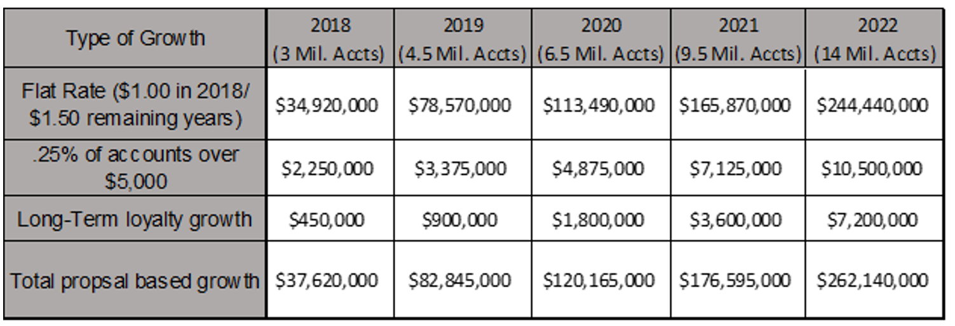

Attachment 5

|  |  |  |  |
| --- | --- | --- | --- |
| Marketing | | | |
| Activity Planning | Specify the Proposed Activity | Implementation Duration; Commencement Time | Annualized Impact on Budget |
| Visits to college campuses/other institutions | 0-6 months; 6-12 months | $4,000,000 |
| Exposure through Facebook | 0-6 months; 6-12 months | $1,000,000 |

|  |  |  |  |
| --- | --- | --- | --- |
| Administrative | | | |
| Activity Planning | Specify the Proposed Activity | Implementation Duration; Commencement Time | Annualized Impact on Budget |
| Hiring of Acorns Employees | 0-6 months; 0-6 months | $530,000 |
| Quality and Regulatory Compliance | 0-6 months; 6-12 months | $20,000 |

|  |  |  |  |
| --- | --- | --- | --- |
| Research and Development | | | |
| Activity Planning | Specify the Proposed Activity | Implementation Duration; Commencement Time | Annualized Impact on Budget |
| Software Analysis Tools | 0-6 months; 6-12 months | $750,000 |
| Rebranding | 6-12 months; 6-12 months | $1,000,000 |
| Quality Development | 0-6 months; 6-12 months | $250,000 |

Attachment 6

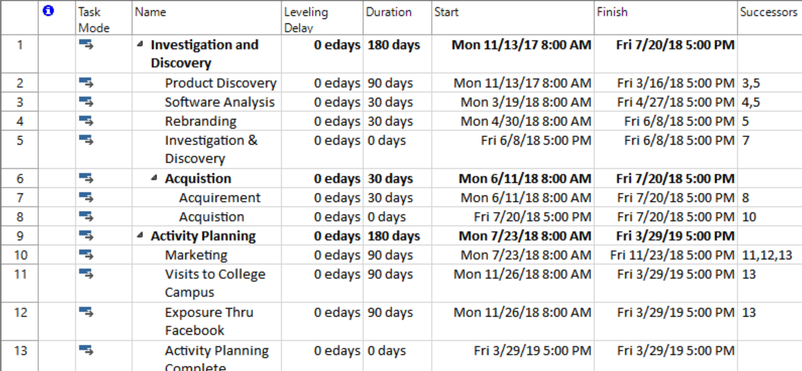

Attachment 7

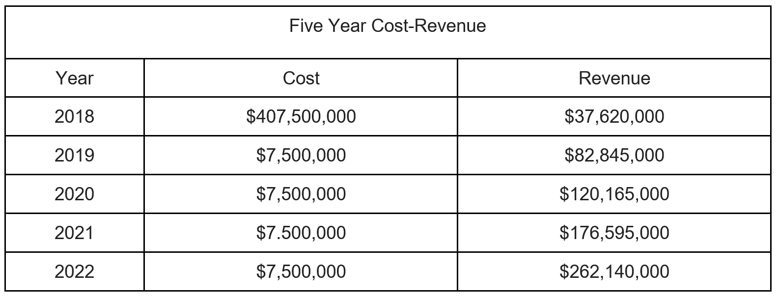

Attachment 8

